Occupational Profile Tool (OPT)

UCGIS Tools User guides

**Table of Content**

About 2

Tools Login & Registration 3

forgot your password 3

create a new account 4

User details and organizations 4

join an organization 5

leave organization 5

create an organization 5

delete your organization 5

create or delete divisions 6

remove users 6

add users 6

Home page 7

share an OP 8

duplicate an OP 8

edit an existing OP 8

create a new (blank) OP 8

default search 8

advanced search 8

search by BoK concept 8

Occupational Profile detail view 10

Create or Edit an Occupational Profile 10

make a profile publicly available 11

find BoK concepts 11

add a concept selected and their related skills 12

remove a knowledge or a skill 12

add a custom skill 12

add transversal skills 13

Glossary of terms 14

## 

## About

The [Occupational Profile Tool](http://ucgis-tools-opt.web.app/) allows users to browse, create, edit and share occupational profiles in the field of Earth Observation and Geographic Information. Profiles are linked to the UCGIS Body of Knowledge (BOK) for EO/GI-specific concepts and skills, to the [European Skills/Competences and Occupation (ESCO) classification](https://ec.europa.eu/esco/portal/skill) for transversal and cross-sectoral skills and to UNESCO’s [International Standard Classification of Education: Fields of Education and Training (ISCED-F)](https://ec.europa.eu/esco/portal/escopedia/International_Standard_Classification_of_Education_58__Fields_of_Education_and_Training_2013__40_ISCED-F_41_) classification for the application field.

The Occupational Profile Tool (OPT) is part of the UCGIS tool suite, and was developed by the [Geospatial Technologies Research Group](http://geotec.uji.es/) (GEOTEC) from the Universitat Jaume I, Castelló de la Plana, Spain.

## Tools Login & Registration

The OPT has two types of users: anonymous and registered users. An anonymous user directly sees public Occupational profiles, without being logged in (See Home page section). A registered user needs to log in and hereby gains access to additional functionalities.

Figure 1 shows the login page from all UCGIS Bok-related tools, including OPT. If you have an account, type in your email (1), your password (2) and click button ‘Login’ (3).

If you

#### **forgot your password**

, type in your email (1) and click ‘Forgot password?’ (4). You will receive an email to recover your password. If you don’t have an account, click Register Now! (5) and proceed to Figure 2 Registration form. You can also sign in with your Google account (6).

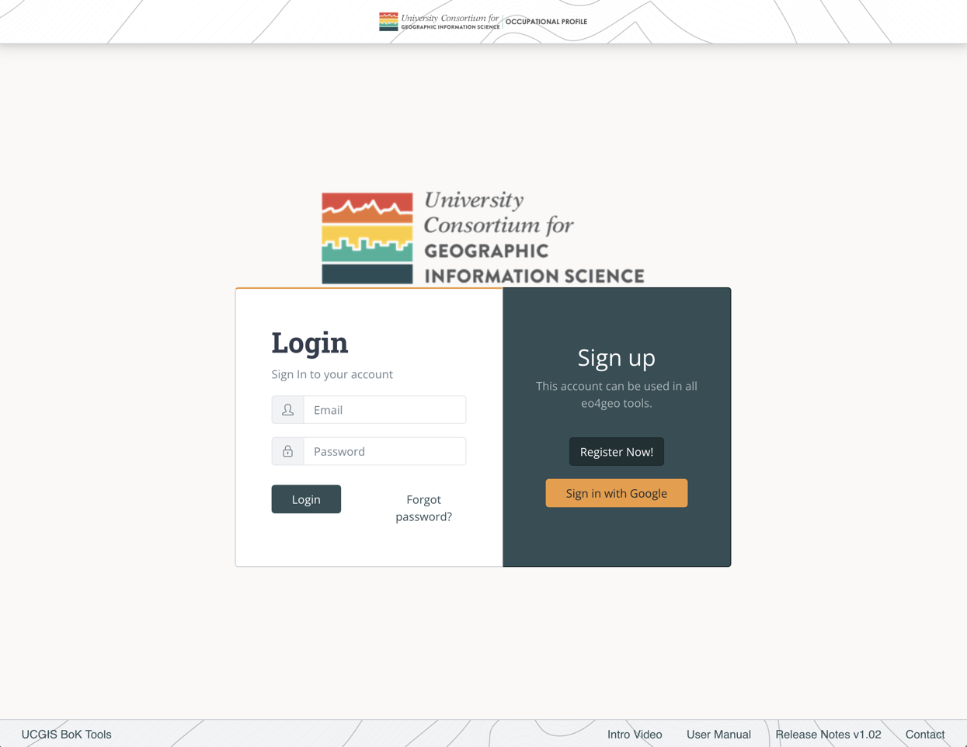

1

2

3

4

5

6

Figure . UCGIS Tools login page

To

#### **create a new account**

, fill in your email (1), your password (2) and repeat your password (3). The password you chose should contain at least 6 characters.

Then click the ‘Register’ button (4) and you will be immediately redirected to the Home page (Figure 2).

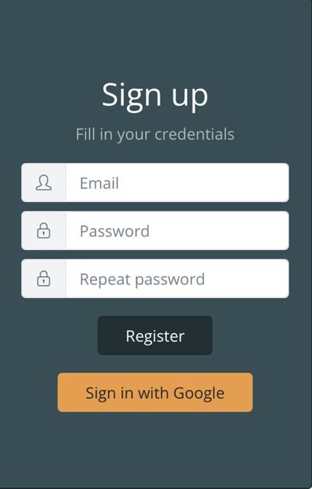

1

2

3

4

Figure . Register form

When registering, if you see the error ‘The email address is already in use by another account’, it means your email is already registered. Write your email in the login part of the form and click ‘Forgot password?’ to receive a link with instructions to recover it.

## 

## User details and organizations

After logging in, the user will be able to see his/her email address in the top navigation bar (Figure 3).



1

2

3

4

Figure 3 Navigation bar

Clicking in the email address (1) the user will be able to save his / her name and recover the password.

Clicking on the ‘Your organization’ (2) link displays every organization the user belongs to. These organizations are important in order to make collaborative edits of the content created in the tool, as users belonging to the same organizations are able to edit content from within these organizations. Also, private content within an organization is not shown to anonymous or external users, but users belonging to the same organization can see it.

To create new content the user needs to belong to at least one organization.

The ‘Home’ button (3) goes to the list page.

The ‘Log Out’ button (4) logs out the user and brings them to the login page.

To

join an organization

, click on the ‘Your organization’ button (2). In the organizations page (Figure 4) click on the dropdown to search for the desired organization. You can type to filter by text. Once you find the desired organization, select it and click Join button (2).

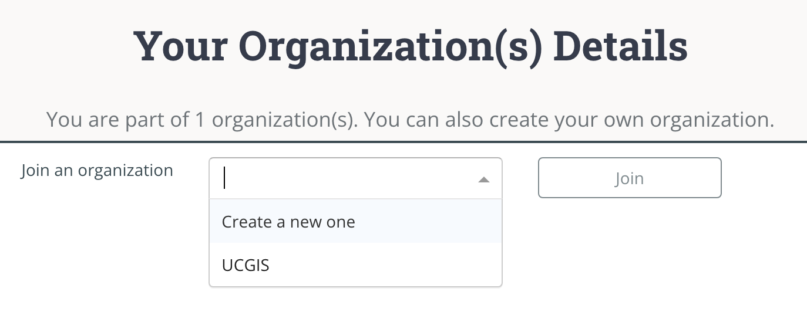

2

1

Figure 4 Dropdown in organizations page

You will be automatically added to that organization as a regular user. You can click on the

leave organization

button to be removed from it (1) (Figure 5).

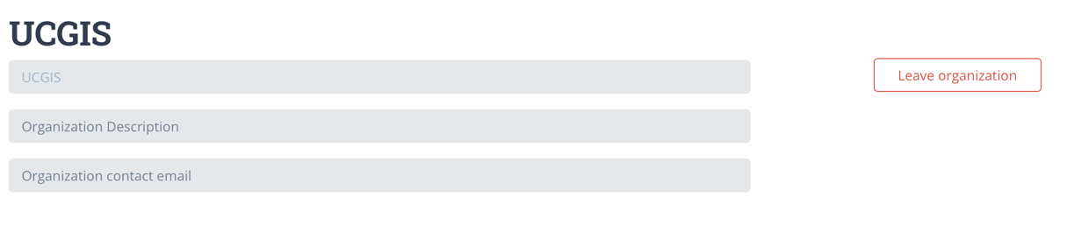

1

Figure 5 A regular user being member of an organization

If you want to

create an organization

select the ‘Create a new one’ option and click on the ‘Join’ button (1) (Figure 6). After that, you can fill in your organization name and description (2) and save changes (3) or you can

delete your organization

(4).

To help in organizing the content inside your organization you can create ‘Divisions’ under an organization. As you are the creator of the organization, that makes you ‘Admin’. As an Admin, you can

create or delete divisions

, by typing the name and ‘Add division’ button (5). They are not compulsory to be able to create content but divisions will help in organizing the content inside your organization.

You can change a user role (Admin / Regular) inside your organization by clicking the button group (6). An admin can also

remove users

(7) of an organization.

Finally, you can

add users

to your organization by typing the email address they used to log in. After your organization is created, new users can also join themselves.

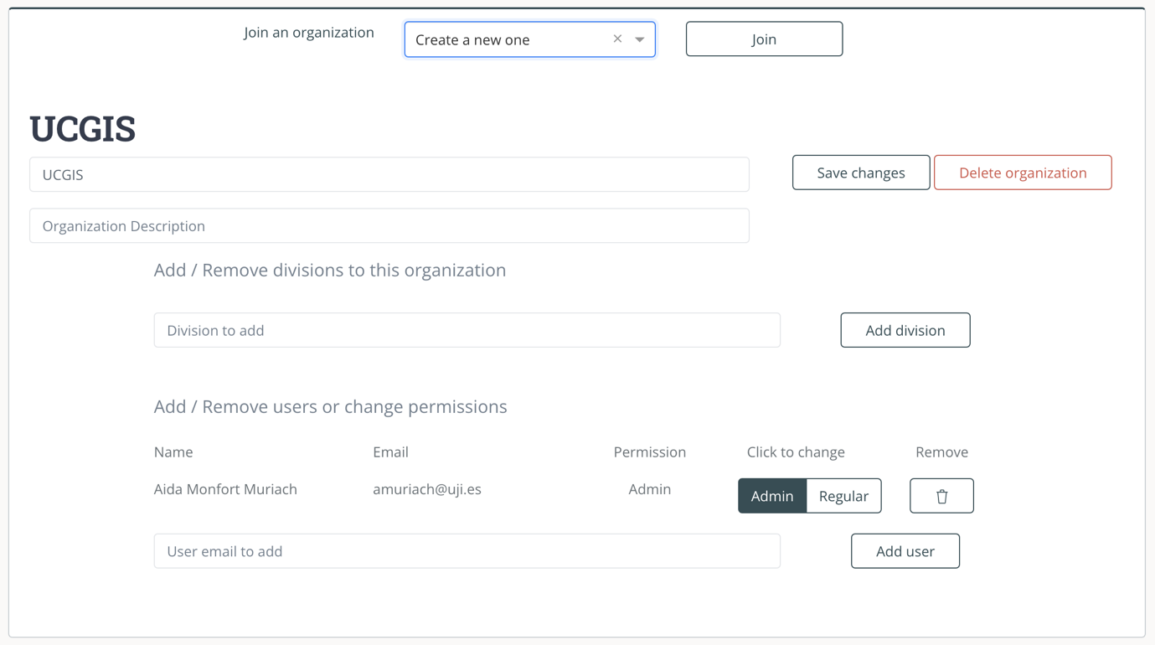

7

6

8

5

4

3

2

1

Figure Organization administration

## Home page

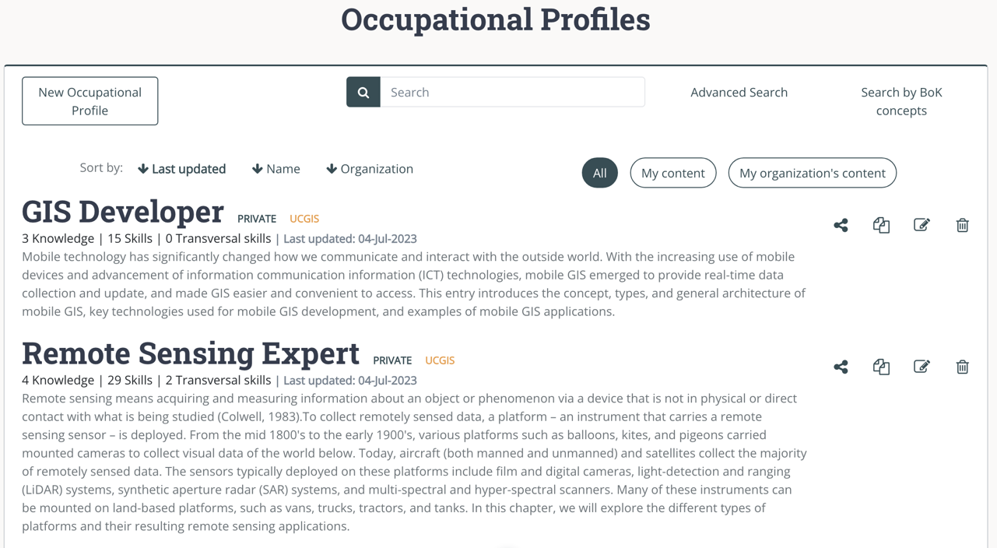Figure 7 shows OPT’s home page with a list of occupational profiles (1). Users see occupational profiles created under his/her organization and the ones saved as public. If the user is not logged in, only public occupational profiles are shown. Per occupational profile its name, its description and a summary of its content is shown.

3

4

8

2

7

6

5

1

Figure . Home page with list of OP

Each OP has a toolbox menu (2), in which the user can find the following options from left to right: share, duplicate, edit and delete (Figure 9). Some actions may be disabled depending on the type of user (anonymous or logged in) (Figure 8).

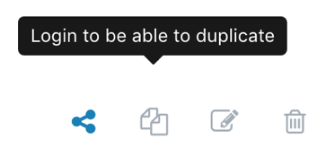

Figure Toolbox with some actions disabled as in the anonymous view

Figure Toolbox with all actions enabled



To

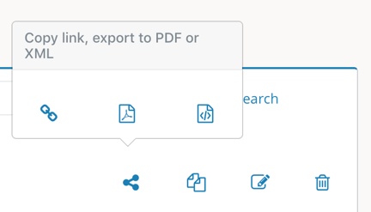

Figure Options to share an OP

#### **share an OP**

, click the ‘Share’ option and select one of the alternatives (from left to right) ‘copy link’, ‘export to pdf’ or ‘export to xml’ format (Figure 10).

To

#### **duplicate an OP**

, the ‘Duplicate’ option creates a new OP which is prefilled with all information from the originating OP. You can then edit this information, rename the OP and save it. This new OP is owned by you, so you can later make modifications to it.

To

#### **edit an existing OP**

, the ‘Edit’ option allows the user to modify those OPs he/she previously created. Finally, the ‘Delete’ option removes an OP. OPs created by other users cannot be edited nor deleted.

To

#### **create a new (blank) OP**

, click the ‘New Occupation Profile’ button (3).

Occupational profiles can be filtered by typing in the search box (4). The

#### **default search**

looks for the text typed in title and description.

If you also need to search in knowledge and/or skills and/or transversal skills click the ‘

#### **advanced search**

’ button (5). Then, enable the options you want to search in by clicking on each switch and type in your search. Occupational profiles will be filtered according to your defined search criteria (Figure 11).

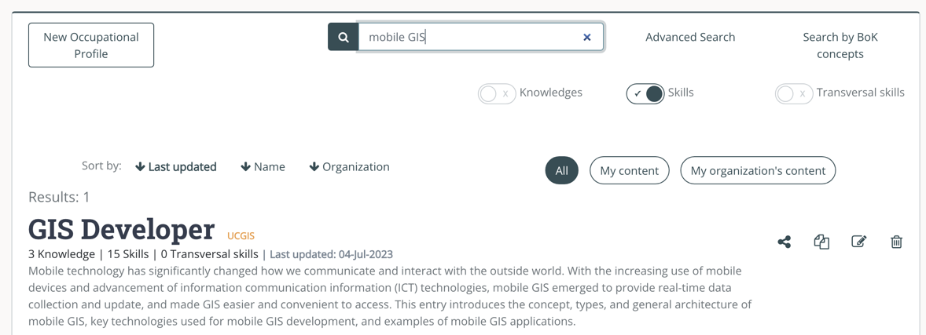

Figure 11 Advanced search in skills

Last search criterion is search by BoK concepts the ‘

#### **search by BoK concept**

**’** (6), if content needs to be filtered by only one knowledge and you know the name of that concept, then you can use Advanced search as explained in the paragraph above, but, if you want to explore the BoK and then select one or more concepts to be filtered by, with search by concept you can do so. Click the link ‘Search by BoK concepts’ and the BoK Visualiser and Search component will open. From there the BoK can be explored and searched, when you find the required concept, select it and continue searching or click on ‘Finish’ to show the filtered results.

To better find and organize the content, occupational profiles can be filtered by who created the content. Click on the button group (7) to filter by your own OPs or OPs created within your organization(s). You can also sort the content by the criteria (8). Click on each criterion to sort ascendent and click again to sort descendent.

## Occupational Profile detail view

The user can see the details of one occupational profile by clicking it (Figure 12).

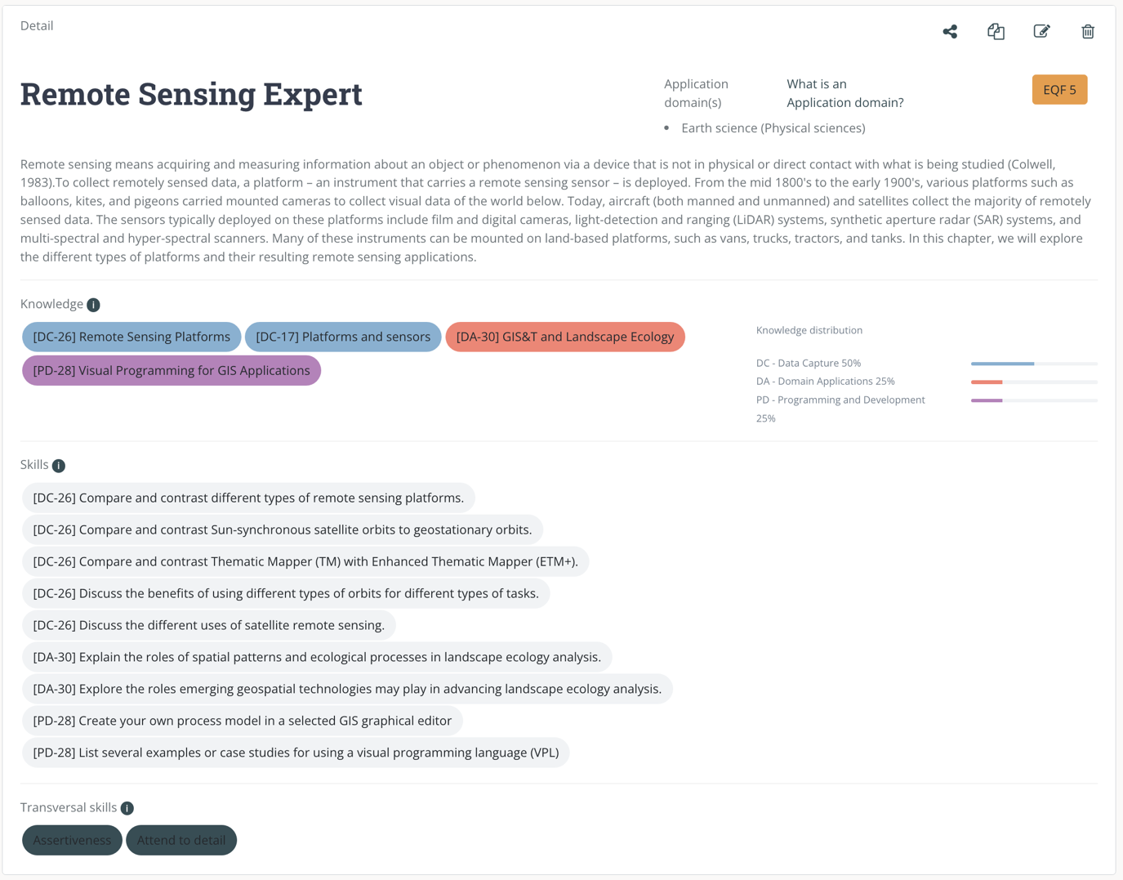

1

2

3

4

5

6

7

8

Figure Detail of an occupational profile

In the detailed view, the different fields of an occupational profile are shown: (1), description (2), field (3), EQF level (4) knowledge (5), skills (6) and transversal skills (7). The distribution of concepts from different areas of knowledge contained in the BoK is presented with progress bars (8).

## Create or Edit an Occupational Profile

Clicking the ‘New Occupational Profile’ button allows you to create a new OP by filling the form. When editing an existing OP the same form will be prefilled with the current information. This form has 4 main sections: General information (Figure 13), the BoK Visualizer to search for Knowledge and Skills and the knowledge and skills already added (Figure 14), and transversal skills view (Figure 16).

Figure 13 shows the form for introducing general information about an OP. ‘Save under organisation’ (1) allows to indicate to which organisation an OP belongs to. This is important as a user will only see OPs under his/her own organisation, even if they are not marked as public, as explained in User details and organizations section. Saving under a division (2) allows to better organize OPs within an organization, division is not mandatory.

If a user decides to

#### **make a profile publicly available**

for the rest of the users outside his/her own organisation, this could be done by switching on ‘Visibility’ from Private to Public (3). ‘Title’ and ‘Description’ are free text fields. The ‘Field’ box (4) contains a list of the Fields of Education and Training by [UNESCO’s ISCED-F](https://ec.europa.eu/esco/portal/escopedia/International_Standard_Classification_of_Education_58__Fields_of_Education_and_Training_2013__40_ISCED-F_41_). Type to search by name of the Field and select the most suitable one(s). The EQF box (2) represents the EQF level required by this OP.

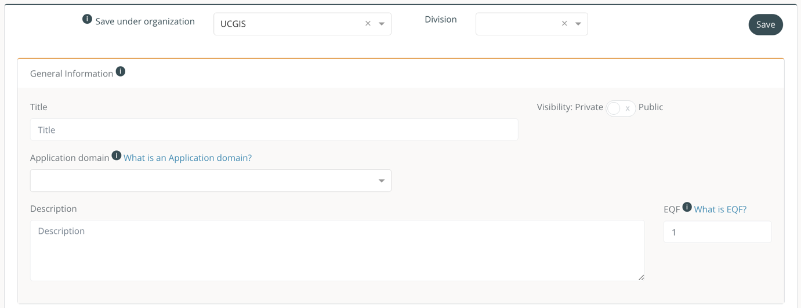

4

3

2

1

Figure OP General Information form

Next section of the OP is ‘Knowledge required’ (Figure 14). This section contains the Body of Knowledge interactive graphical and textual browser.

To

#### **find BoK concepts**

, there are two options: searching or browsing. To search, type your search term(s) in the search box (1) to filter BoK concepts containing the text either in the name or in the description. Matching concepts are highlighted in the graph.

To browse, click on any part of the graphical BoK (2) to navigate through the concepts. Alternatively, you can also browse using the links in the textual view (3). Click on the ‘Details’ link to see the full information of a concept.

2

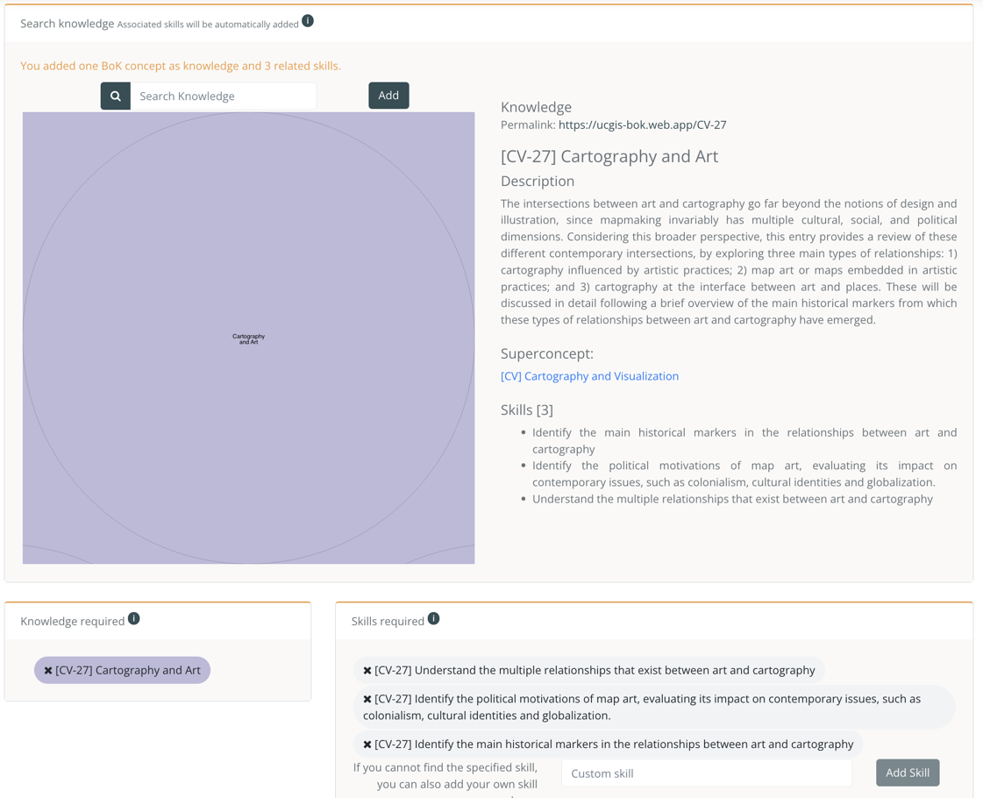

4

5

3

2

1

Figure Selecting knowledge and skills as required

Once you find the concept you need, to

#### **add a concept selected and their related skills**

, click the ‘Add’ button (1) and the concept selected (2) and their related skills (3) will be automatically added to ‘Knowledge required’ (4) and ‘Skills required’ (5) respectively, in a pill-shaped button (Figure 14). Each button contains a code between brackets (coming from the BoK) and its name. The knowledge pill buttons’ colour depends on the Knowledge area they belong to. To

#### **remove a knowledge or a skill**

that was added previously, click on the ‘x’ symbol close to the knowledge or skills to be removed and the list will be updated. If you remove a ‘Knowledge required’ the system will ask you whether to delete or keep all its associated ‘Skills’.

You can

#### **add a custom skill**

by writing them in text box (1) and then clicking on ‘Add Skill’ button (2). (Figure 15)

To

Figure Add custom skill

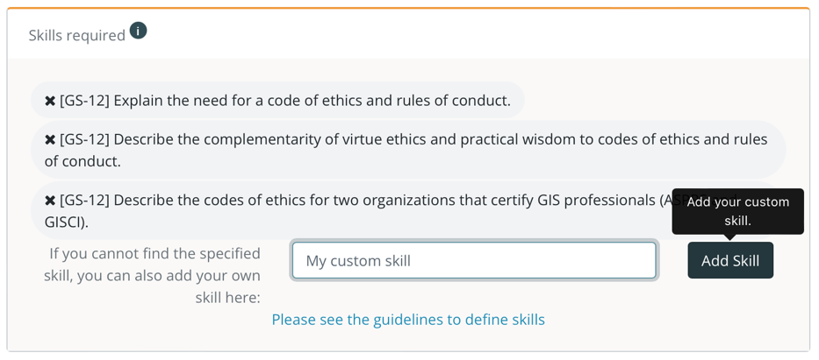

1

2

#### **add transversal skills**

(Figure 16) they should be selected from a closed list that contains a selection of skills from the ESCO classification (1). Typing in the text box filters in the list. Clicking on the switch (2) allows a full search on all ESCO skills. If a specific transversal skill is not found, this can be added as a custom skill, by typing it in custom skill text box (3) and then clicking the ‘Add transversal skill’ button (4). To remove a transversal skill, click the ‘x’ symbol and the list will be updated (5).

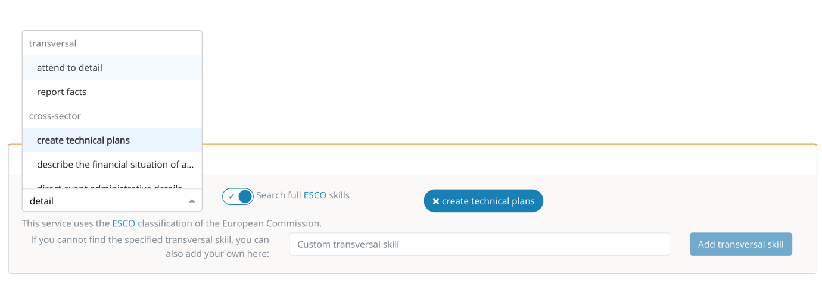

1

2

3

4

5

Figure Transversal skills

# Glossary of terms

**ESCO.** Classification of European Skills, Competences, Qualifications and Occupations

**EQF.** The European Qualifications Framework for Lifelong Learning. The core of the EQF concerns eight reference levels describing what a learner knows, understands and is able to do, ranging from basic (Level 1) to advanced (Level 8)

<https://ec.europa.eu/ploteus/sites/eac-eqf/files/broch_en.pdf>

**Field**. Term related to a specific area of study, following the ISCED-F classification

**ISCED-F**. International Standard Classification of Education: Fields of Education and Training 2013, maintained by UNESCO.

<https://ec.europa.eu/esco/portal/escopedia/International_Standard_Classification_of_Education_58__Fields_of_Education_and_Training_2013__40_ISCED-F_41_>

**Knowledge.** The body of facts, principles and theories and practices that is related to a field of work or study

**Skills** means the ability to apply knowledge and use know-how to complete tasks and solve problems.

**Transversal Skills** are those typically considered as not specifically related to a particular job, task, academic discipline or area of knowledge but as skills that can be used in a wide variety of situations and work settings, since they are a combination of people skills, social skills, communication skills, character or personality traits, attitudes, career attributes, social intelligence and emotional intelligence quotients, among others, that enable people to navigate their environment, work well with others, perform well, and achieve their goals with complementing hard skills.